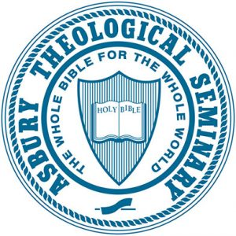

Asbury Theological Seminary Syllabus
DM 911B: Discovering God’s Missional Heart - Two
2.00 Credit Hours
Extended Learning/Online course
2020 Fall Session/Sep 8, 2020 – Dec 18, 2020
PROFESSOR INFORMATION

Name: Stephen (Steve) Seamands
Title: Professor Emeritus
Email: steve.seamands@asburyseminary.edu
Office Location:
Office Hours:

Name: Dr. Gregg Okesson
Title: Ira Galloway and D.M. Beeson Chair of Leadership Development, Mission and Evangelism; Acting Provost
Email: gregg.okesson@asburyseminary.edu
Office Location: MC309
Office Hours: Email for appointment

COURSE DESCRIPTION

This course is foundational to the Asbury Seminary D.Min. experience. The course's design is built on this claim: lasting ministry is an effect of a life that is deeply derived from God's nature and image. The course examines the practice of ministry by fostering a critical theological understanding of the purpose of Christian ministry within the broader context of the nature and mission of the Church. It also seeks to provide biblical, theological and missiological insights which can inform specific functions of ministry. The course is intended to assist participants in formulating and clarifying theological bases from which their vocations in ministry flow. It assists them in reflection upon core elements of how their theological lineages impact their ministry philosophies, and their expressions of mission, witness and ministry.

PROGRAM LEARNING OUTCOMES
By the time students complete the D.Min Program, they will have an accomplished or exceptional ability to:
1. Revisit foundations for sustainable ministry.
- Being immersed in explicit Wesleyan practices of community-based formation around the priorities of scripture, reason, tradition and experience, participants will discover transformational habits for sustainable ministry lifestyles.
2. Foster ministry leadership vision, ethic and practice relevant to their ministry context and world.
- By deeply engaging in analysis of one significant theme from their unique ministry context, participants establish a trajectory for life-long contribution.
3. Appreciate transformational demands within contemporary ministry organizational contexts such as congregations, non-profits and marketplace engagements through various analytic means of biblical, theological, social and cultural exegesis.
- Participants must add to their biblical and theological exegesis, cultural- situational exegesis that informs ministry leadership practice on a daily basis.
REQUIRED STUDENT LEARNING OUTCOMES
By the end of DM911B, students will have an accomplished to exceptional ability to:
1. Understand and articulate essential biblical and theological concepts, along with key social science insights, with a view to formulating a transformative theology of mission for their understanding and practice of ministry that is resonant, faithful and sustainable in various contexts. (PLO # 1)

2. Relate their understanding of transformative theology of mission to both their public world (global, social, ecclesial) and private world (personal, devotional, interpersonal) so as to establish ministry understandings and practices for various contexts that are resonant, faithful and sustainable. (PLO # 2)

3. Demonstrate scholarly skills in biblical and theological reading and reflection by applying their understanding of transformative theology of mission, along with key social sciences insights, to particular ministry situations and contexts. (PLO #2)

4. Appreciate the diversity of Christian witness around the world through peer formation groups. (PLO #3)

ADDITIONAL STUDENT LEARNING OUTCOMES

N/A

COURSE INTRODUCTION

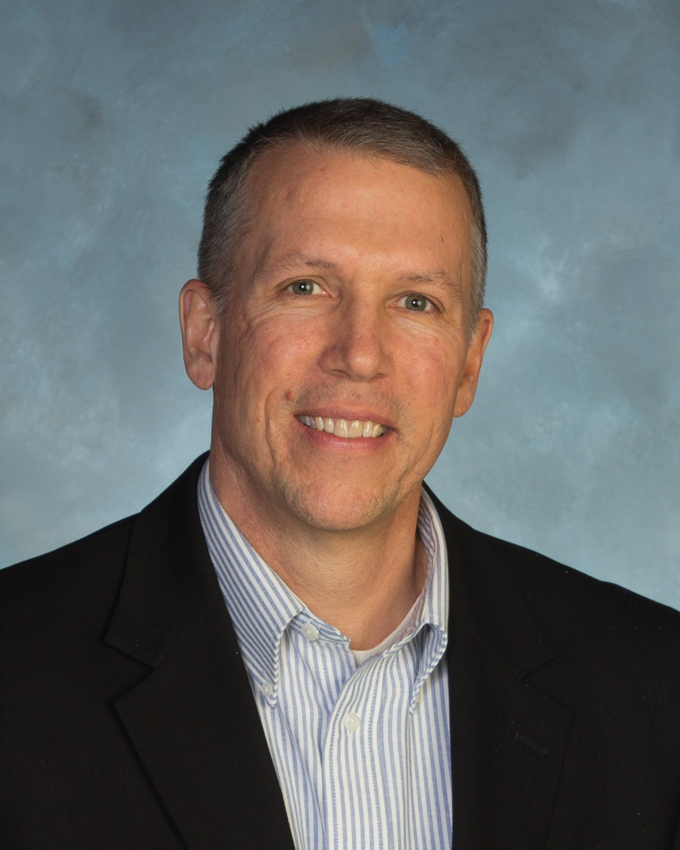

Welcome to Discovering God’s Missional Heart! The information below provides an introduction to your teaching team.
Steve Seamands, Ph.D. joined the Asbury Seminary faculty in 1983 after serving eleven years as a United Methodist pastor in southern New Jersey. Dr. Seamands is known for gracefully merging theology and practice and considers himself, above all, to be a pastoral theologian. His courses on theology and doctrine are taught with a scholar’s mind and a pastor’s heart. He is the author of seven books: Christology and Transition in the Theology of Edwin Lewis (University Press of America, 1987); Holiness of Heart and Life (Abingdon Press, 1990); A Conversation with Jesus (Victor Books, 1994); Wounds that Heal (InterVarsity Press, 2003); Ministry in the Image of God (InterVarsity Press, 2005), which was chosen by Christianity Today for the “Award of Merit” for books in the area of church and pastoral leadership for 2005; Give Them Christ: Preaching His Incarnation, Crucifixion, Resurrection, and Return (InterVarsity Press, 2012); and The Unseen Real (Seedbed, 2016). His published works also include contributions to numerous journals and magazines.
Gregg Okesson, Ph.D. joined the Asbury Seminary faculty in 2011. As a former missions practitioner in East Africa (Tanzania and Kenya) for more than 13 years, Dr. Okesson fosters missional formation from the stance of a leadership development practitioner and mentor. He was a faculty member at Scott Theological College/Scott Christian University, Kenya, East Africa where he served as Deputy Vice Chancellor for Academic Affairs. Prior to this, he was a pastor in Upstate New York, worked in Student Development at Wheaton College, and was a church-planter among a Muslim people- group in north-central Tanzania. Dr. Okesson has authored numerous articles and book chapters, as well as serving on the editorial committee for the Africa Journal of Evangelical Theology and the Africa Study Bible. He is the author of Re-Imaging Modernity (Wipf & Stock, 2012), co-author of Advocating for Justice (Baker Academic, 2016); and A Public Missiology: How Churches Witness in a Complex World (Baker Academic, 2020).

REQUIRED TEXTBOOKS

Barton, Ruth Haley. Strengthening the Soul of Your Leadership: Seeking God in the Crucible of Ministry. IVP Books: 2018. (240 pages)

$16.10 Hardback, ISBN: 978-0830846450
$9.99 Kindle, ASIN: B00DVQSEA8

Fernando, Ajith. Jesus Driven Ministry. Crossway: 2007. (258 pages)

$15.57 Paperback, ISBN: 978-1581348514
$9.99 Kindle, ASIN: B0029RJ7DS

Newbigin, Lesslie. The Open Secret: An Introduction to the Theology of Mission. Eerdmans, Revised ed.: 1995. (200 pages)

$14.59 Paperback, ISBN: 978-0802808295
$13.86 Kindle, ASIN: B001E95TCA

Okesson, Gregg. A Public Missiology: How Local Churches Witness to a Complex World. Baker Academic: 2020. (272 pages)

$24.99 Paperback, ISBN: 978-0801098079
$13.99 Kindle, ASIN: B07VQMH6R9

Scazzero, Peter. The Emotionally Healthy Leader. Zondervan: 2015. (336 pages)

$14.99 Paperback, ISBN: 978-0310525363
$9.99 Kindle, ASIN: B00PFC9MR0

Seamands, Stephen. Ministry in the Image of God: the Trinitarian Shape of Christian Service. IVP Books: 2005. (189 pages)

$13.99 Paperback, ISBN: 978-0830833382
$9.99 Kindle, ASIN: B001HN6KQM

Volf, Miroslav. A Public Faith: How Followers of Christ Should Serve the Common Good. Brazos Press: 2011. (193 pages)

$12.98 Paperback, ISBN: 978-1587432989
$9.99 Kindle, ASIN: B0053XXDOY

Wright, Chris. The Mission of God’s People: A Biblical Theology of the Church’s Mission. Zondervan: 2010. (304 pages)

$20.49 Paperback, ISBN: 978-0310291121
$17.49 Kindle, ASIN: B003TFE8L0
Total pages: 1,992 (plus articles in online classroom)
REQUIRED RESOURCES

N/A

RECOMMENDED TEXTBOOKS

Seamands, Stephen. Wounds that Heal: Bringing Our Hurts to the Cross. IVP Books: 2003. (192 pages)

$15.07 Paperback, ISBN-13: 978-0830832255
Not available in Kindle format.

Sider, Ronald, Phillip Olson, and Heidi Rolland Unruh. Churches That Make a Difference: Reaching Your Community with Good News and Good Works. Baker Books: 2002. (338 pages)

$20.00 Paperback, ISBN: 978-0801091339
$14.75 Kindle, ASIN: B0090OH1GI

RECOMMENDED RESOURCES

N/A

ASSIGNMENTS AND RUBRICS OR EVALUATION CRITERIA

To successfully complete this class, students must satisfactorily complete and submit all assignments on time and actively participate and contribute to the learning community.
1. Reflection Paper (80 points)
Due Date: October 12, 2020
Points/Percentage: 80
Learning Outcome: 2
Write a 13-15 page reflection paper, based on your reading of course texts and processing of class sessions, on “The Impact of a Theology of Transformative Mission on the Public (global, social and ecclesial) and Private (personal, devotional, interpersonal) Dimensions of My Life and Ministry.” You may choose to focus your paper on your life and ministry in general. OR you may focus your paper specifically on a particular problem/issue you have been currently wrestling with in your life and ministry. Make sure that in your paper you (a) interact with specific ideas in the course texts; (b) discuss key concepts presented in class; and (c) relate ideas and concepts to specific aspects of your life and ministry.
2. Global Christian Witness Impact Report (20 points)
Due Date: October 26, 2020
Points/Percentage: 20
Learning Outcome: 4
Complete the “Global Christian Witness Impact Report” that is provided in your DM911B online classroom. You will identify specific examples of how peer-to-peer learning during the August residency with leaders from around the world is impacting your transformative theology of mission for the understanding and practice of ministry.
Assignment Description | SLO | Method of Assessment | Value /Due Date | Evaluator
Assignment #1: Reflection Paper | #2 | 13-15 page paper | 80%  Due: 10/12/2020.  Upload to online classroom. | Faculty: Seamands
Assignment #2: Global Christian Witness Impact Report | #4 | Completed report | 20%  Due: 10/26/2020.  Upload to online classroom. | Faculty: Seamands

COURSE SCHEDULE
N/A
ADDITIONAL ASSIGNMENT GUIDELINES

See next pages.

Student Learning Outcomes | Method of Assessment | Exemplary=4 | Accomplished=3 | Developing=2 | Beginning=1 | Evaluator
SLO #2: Relate their understanding of transformative theology of mission to both their public world (global, social, ecclesial) and private world (personal, devotional, interpersonal) so as to establish ministry understandings and practices for various contexts that are resonant, faithful and sustainable. | Reflection Paper | Relate, at an exemplary level, their understanding of transformative theology of mission to both their public world (global, social, ecclesial) and private world (personal, devotional, interpersonal) so as to establish ministry understandings and practices for various contexts that are resonant, faithful and sustainable. | Relate, at an accomplished level, their understanding of transformative theology of mission to both their public world (global, social, ecclesial) and private world (personal, devotional, interpersonal) so as to establish ministry understandings and practices for various contexts that are resonant, faithful and sustainable. | Relate, at a developing level, their understanding of transformative theology of mission to both their public world (global, social, ecclesial) and private world (personal, devotional, interpersonal) so as to establish ministry understandings and practices for various contexts that are resonant, faithful and sustainable. | Relate, at a beginning level, their understanding of transformative theology of mission to both their public world (global, social, ecclesial) and private world (personal, devotional, interpersonal) so as to establish ministry understandings and practices for various contexts that are resonant, faithful and sustainable. | Faculty
SLO #4: Appreciate the diversity of Christian witness around the world through peer formation groups. | Global Christian Witness Impact Report | Appreciate, at an exemplary level, the diversity of Christian witness around the world through peer formation groups. | Appreciate, at an accomplished level, the diversity of Christian witness around the world through peer formation groups. | Appreciate, at a developing level, the diversity of Christian witness around the world through peer formation groups. | Appreciate, at a beginning level, the diversity of Christian witness around the world through peer formation groups. | Faculty

Attendance/Participation: To progress satisfactorily and achieve learning outcomes in this class, students must meet the course requirements. Students are responsible for notifying instructors of the reason for any absences as soon as possible and are accountable for all assignments. Makeup quizzes or exams are generally not permitted unless previously arranged with the instructor. Each faculty member will provide a written attendance policy for each class and also go over that policy on the first day of class for the course. Refer to the ATS Student Handbook for additional information regarding attendance policies and excused absences.
Late Assignments: Any assignment submitted after the due date and time will be reduced two numerical points for every day late. For example, two days late would reduce the grade from a 90 to an 86, unless the student talks to the professor ahead of time and receives permission to turn in the assignment late, based upon a legitimate excuse (such as illness).
Format of Papers: Students must use MLA academic style for completing papers; this is also the required style for your dissertation.
INCOMPLETE WORK POLICY
Incomplete Work: “A grade of ‘I’ denotes that course work has not been completed due to an unavoidable emergency. Delinquency or attending to church work or other employment does not constitute an unavoidable emergency. Without an approved ‘I,’ a letter grade will be recorded based on grades received for completed work and an ‘F’ grade assigned to incomplete work” (ATS 2015-16 Student Handbook, page 67).
Letter | Lowest | Highest
A | 94.00% | 100.00%
A- | 90.00% | 93.99%
B+ | 87.00% | 89.99%
B | 84.00% | 86.99%
B- | 80.00% | 83.99%
C+ | 77.00% | 79.99%
C | 74.00% | 76.99%
C- | 70.00% | 73.99%
D+ | 67.00% | 69.99%
D | 64.00% | 66.99%
D- | 60.00% | 63.99%
F | 0.00% | 59.99%
The unit of credit is a semester hour, which is defined as one hour of classroom work per week for one semester, or its equivalent. The 4.00 point system is used to compute grade point standing. The grading system is:
GRADE | EVALUATION CRITERIA
A | Exceptional work: surpassing outstanding achievement of course objectives
B | Good work: strong, significant achievement of course objectives
C | Acceptable work: basic, essential achievement of course objectives
D | Marginal work: inadequate, minimal achievement of course objectives
F | Unacceptable work: failure to achieve course objectives

GRADING

Assignment | Weight/Point Value
Reflection Paper | 80
Global Christian Witness Impact Report | 20
 | Total: 100

CANVAS (LEARNING MANAGEMENT SYSTEM)
Canvas is the learning management system used for Asbury seminary classes. Log into http://connect.asburyseminary.edu and click on the flashing cube (upper right corner) to access a link to the Canvas website. Once you have logged in, it is recommended that you bookmark this page for easy access. The courses that you are enrolled in should appear as “course cards” on your Dashboard. You may navigate to your desired course here. If you do not see your course, or there is nothing in your course, please contact your professor.

COURSE EVALUATIONS

Course evaluations are a vital part of Asbury Seminary’s efforts to achieve excellence in the classroom. At the end of the semester, you will receive an email with information and directions for completing course evaluations. Your responses are completely anonymous, and your participation is greatly appreciated. If you have questions or encounter problems accessing the evaluations, contact the Help Desk at helpdesk@asburyseminary.edu or by phone at 859.858.2100 or toll-free at 800.2ASBURY.

TECHNOLOGY REQUIREMENTS & SUPPORT
To take an online or hybrid class, you should be comfortable using e-mail, web browsers, word-processing software and be able to download files and create attachments. You will need the following in order to participate online:
- A computer with Windows 7 or MAC OS 10.6 or above
- An account with or regular access to an internet service provider (ISP)
- Reliable, high-speed internet (recommended)
- Word processing software
- A webcam (built-in or external) for video conferences, as needed
- A headset with microphone (preferable)
Contact the Help Desk for technical assistance accessing the online class, using electronic resources, or with other technical issues related to Asbury Seminary coursework.
- Email: helpdesk@asburyseminary.edu
- Phone: 859.858.2100 or 800.2ASBURY (toll free)
LIBRARY RESOURCES
Library resources, research support, and library loan are available via:
- Website: asbury.to/library
- Email: helpdesk@asburyseminary.edu
- Phone: 859.858.2100 or 800.2ASBURY (toll free)
Materials Requests
Use the links on the library website to search the library catalog for available materials. Students on the Kentucky or Florida campuses can use their student ID cards to check out materials in person. Books can be returned or mailed to the library at either the Kentucky or Florida campus.
Students may request books, photocopies, or emailed attachments of journal articles or portions of reference books from the library. Allow 3-10 business days for requests to be filled. Contact the library for costs and instructions on how to make requests, or view the online tutorial at guides.asburyseminary.edu/libraryloan.
Online Resources
- Asbury Scholar – Find library books, ebooks, journal articles, and other media at asbury.to/library.
- Databases – Access links to online resources including the library catalog, online journal databases, encyclopedias, and more at guides.asburyseminary.edu/az.php.
Research Assistance
Students should contact Research Services in the library for research assistance. Help is available for general research questions, including how to find course materials online or navigate library resources. Training for supported Bible software or bibliographic management software is also available. Appointments can be made via:
- Website: asbury.to/library
- Email: helpdesk@asburyseminary.edu
- Phone: 859.858.2100 or 800.2ASBURY (toll free)
The Writing Center
- The goal of the Writing Center is to help students improve their graduate-level writing. Assistance is available both online and on the Kentucky campus to help with various aspects of the writing process, including structure and organization, grammar, punctuation, and citation formatting. Appointments can be made by contacting the library via:
  - Website: asbury.to/writingcenter
  - Email: helpdesk@asburyseminary.edu
  - Phone: 859.858.2100 or 800.2ASBURY (toll free)
- Students can sign up for 30-minute sessions on the library website at asbury.to/library.
POLICIES
Each student is responsible for being familiar with seminary policies. Asbury Seminary reserves the right to change policies when necessary. Below are brief descriptions of a few seminary policies. For more detailed information regarding school policies, please refer to the ATS Student Handbook at asburyseminary.edu/students/student-services/student-handbook/
Disability Accommodations
Asbury Theological Seminary provides reasonable accommodation on an individualized basis for qualified students with disabilities. Students are required to provide documentation of a disability prior to receiving classroom accommodations. Since accommodations may require early planning before or at the start of the term and are generally not provided retroactively, students need to contact an Accommodations Officer as soon as possible. If you are a student with a disability and believe you require reasonable accommodations in this class, you will need to make an appointment with an Accommodations Officer in the Office of the Registrar on the Kentucky campus or in the Enrollment Management Office on the Florida campus. Students attending the Tennessee site should contact the Kentucky Registrar.
Academic Integrity
Academic integrity is expected of every student. Plagiarism, that is, “presenting … another’s ideas or writings as one’s own,” is considered a serious violation of integrity and is unacceptable. Detailed information, including the penalty for plagiarizing, is in the Student Handbook. For additional information about plagiarism, go to plagiarism.org.
In this course we may utilize Unicheck, an automated system that compares students’ assignments with websites as well as a database of previously submitted student work. After the assignment is processed, instructors receive a report from unicheck.com (through SpeedGrader™) that states if and how another person’s work was used in the assignment. For more information, see www.unicheck.com. If you have questions about academic honesty, please contact the library at helpdesk@asburyseminary.edu.
Copyright Information
The copyright law of the United States (title 17, United States Code) governs the making of photocopies or other reproductions of copyrighted material. Under certain conditions specified in the law, libraries and archives are authorized to furnish a photocopy or other reproduction. One of these specific conditions is that the photocopy or reproduction is not to be "used for any purpose other than private study, scholarship, or research." If a user makes a request for, or later uses, a photocopy or reproduction for purposes in excess of "fair use," that user may be liable for copyright infringement. This institution reserves the right to refuse to accept a copying order if, in its judgment, fulfillment of the order would involve violation of copyright law.
By using online media resources, students are consenting to abide by this copyright policy. Any duplication, reproduction, or modification of this material without express written consent from Asbury Theological Seminary and/or the original publisher is strictly prohibited.
ZOOM
Courses may use Zoom for synchronous online instruction. These sessions may be recorded by the professor and posted into the Canvas classroom. The recorded sessions will not be downloadable, and will not be used by the professor in future classes unless there is documented permission from all of the students in the recording. Chat rooms in a Zoom call are recorded and discretion should be exercised when using the chat feature, including in private rooms.
Video recordings may be considered educational records under the Family Education Rights & Privacy Act (FERPA) and will be protected as such by the Seminary. Zoom collects only minimal client information and ensures that information is kept secure (https://zoom.us/docs/doc/FERPA%20Guide.pdf).
Requests for accessibility accommodations related to Zoom will be dealt with on a case-by-case basis as described above under Disability Accommodations.
APPENDIX

N/A

